INNOVATIVE PROJECT DEVELOPMENT REPORT

AI Interview Preparation And Feedback System
In partial fulfillment of theAcademic Requirements for the Degree of
BACHELOR OF TECHNOLOGY

Computer Science & Engineering

ABSTRACT
The AI Interview Preparation and Feedback System is an intelligent platform designed to help students and job seekers improve their interview skills through automated mock interviews and personalized feedback. The system uses Artificial Intelligence technologies such as Natural Language Processing (NLP), Machine Learning (ML), and speech analysis to simulate real interview scenarios.
This system allows users to practice technical, aptitude, and HR interview questions. It analyzes the candidate's responses based on correctness, confidence, communication skills, and response time. The AI then provides detailed feedback, highlighting strengths and areas that need improvement. It may also suggest model answers and learning resources for better preparation.
Additionally, the system can track user performance over time and provide progress reports to help candidates understand their development. By providing a realistic interview environment, this platform helps reduce interview anxiety and increases candidate confidence.
One of the key features of this system is the automated feedback mechanism. After each mock interview session, the system provides detailed feedback highlighting the candidate’s strengths and weaknesses. It may also suggest improvements in communication, provide correct or model answers, and recommend topics for further study. The system can also assign scores based on performance metrics, helping users understand their readiness level for real interviews.
Additionally, the system maintains user performance history and generates progress reports. This helps candidates track their improvement over time and identify areas requiring more attention. The platform may also include features such as frequently asked interview questions, company-specific interview patterns, resume-based question generation, and AI-based suggestions for better answering strategies.
Overall, the AI Interview Preparation and Feedback System aims to make interview preparation more efficient, accessible, and data-driven, helping candidates enhance their skills and improve their chances of success in job interviews.

INDEX
TITLE | PAGE NO
1. INTRODUCTION | 1 - 3
2. SYSTEM STUDY | 4
3. REQUIREMENTANALYSIS | 5 - 7
4. SYSTEM DESIGN | 8 - 10
5. MODULES | 11 - 12
6. ALGORITHMS | 13
7. SYSTEM TEST ,SOURCE CODE | 14 - 19
8. INPUTAND OUTPUT DESIGN | 20 - 22
9. CONCLUSION | 23
10. FUTURE SCOPE | 24
11. REFERENCES | 25

CHAPTER 1

INTRODUCTION
In today's highly competitive job market, performing well in interviews is a critical requirement for securing employment. While many candidates possess strong technical knowledge, they often struggle to present their skills effectively during interviews due to lack of practice, poor communication skills, nervousness, or absence of proper feedback[1]. Traditional interview preparation methods such as reading questions, practicing with friends, or attending coaching sessions may not always provide personalized evaluation or real interview experience. Therefore, there is a need for an intelligent system that can help candidates practice interviews and receive constructive feedback.
The AI Interview Preparation and Feedback System is designed to solve this problem by providing a smart and automated interview preparation platform. This system uses Artificial Intelligence (AI) to simulate real interview environments where candidates can practice answering questions related to technical subjects, aptitude, and human resources (HR) topics. By integrating technologies such as Machine Learning (ML)[2], Natural Language Processing (NLP), and data analysis, the system can understand candidate responses and provide meaningful feedback.
This platform allows users to take mock interviews through text or voice interaction. The AI evaluates the answers based on different factors such as correctness, confidence, communication clarity, response time, and completeness of the answer. Based on this analysis, the system generates a performance report that highlights both strengths and areas needing improvement. This helps candidates identify their mistakes and improve their interview performance systematically.
In conclusion, the AI Interview Preparation and Feedback System acts as a virtual interview coach that helps candidates improve their knowledge presentation, communication ability, and confidence.
EXISTING SYSTEM:
The existing systems for interview preparation mainly include traditional methods[1] such as classroom training, placement training programs, online question banks, and mock interviews conducted by trainers or peers. Most students prepare for interviews by reading frequently asked interview questions, watching videos, or practicing with friends. While these methods provide basic preparation, they have several limitations.
Currently, many online platforms provide interview preparation materials[8][9] such as questions and answers, coding practice websites, and aptitude tests. Some platforms also provide mock interviews, but they often require human interviewers, which may not always be available. Additionally, these systems usually do not provide instant or detailed personalized feedback about the candidate's performance.
Another major drawback of the existing system is the lack of continuous performance tracking. Most traditional preparation methods do not maintain detailed records of candidate progress or provide data-driven suggestions for improvement. Feedback, if provided, is often general rather than personalized. Also, manual mock interviews can be time-consuming and may involve scheduling difficulties.
In many cases, candidates do not get proper evaluation of their communication skills, confidence level, and response quality. Existing systems also do not effectively analyze behavioral aspects such as hesitation, speaking speed, or clarity of answers. As a result, candidates may not clearly understand their weaknesses until they face real interviews.
PROPOSED SYSTEM
The proposed AI Interview Preparation and Feedback System is an intelligent and automated platform designed to overcome the limitations of traditional interview preparation methods. The system provides a virtual interview environment where candidates can practice different types of interview questions and receive instant, personalized feedback without the need for a human interviewer.
The proposed system uses Artificial Intelligence techniques[2] such as Machine Learning (ML), Natural Language Processing (NLP), and speech/text analysis to evaluate candidate responses. The system can automatically generate questions from different categories such as technical, HR, behavioral, and aptitude topics. Candidates can attend mock interviews through a web or mobile interface and submit their responses either in text form or through voice input.
The main feature of the proposed system is its intelligent evaluation mechanism. After the candidate answers a question, the AI analyzes the response based on multiple parameters such as answer relevance, correctness, confidence, communication clarity, grammar, and response time. Based on this analysis, the system generates a detailed feedback report. This report includes performance scores, mistakes, improvement suggestions, and sample answers to help candidates learn the correct approach.
The system also includes a performance tracking module that stores candidate results and shows progress over time. This helps users identify their improvement areas and measure their readiness for real interviews. The platform may also include additional features such as resume-based question generation, company-specific interview question sets, frequently asked questions, and AIbased preparation tips.
The proposed system is designed to be user-friendly, flexible, and accessible. Since it can be implemented as an online platform, candidates can practice interviews anytime and anywhere. This reduces dependency on coaching centers and makes interview preparation more cost-effective and scalable.

CHAPTER 2

FEASIBILITY STUDY
The feasibility study of the AI Interview Preparation and Feedback System is conducted to determine whether the proposed system is practical, cost-effective, and technically possible to implement. It evaluates different factors such as technical feasibility, economic feasibility, operational feasibility, and time feasibility to ensure the successful development of the project.
- Technical Feasibility
Technical feasibility refers to whether the required technology, tools, and resources are available to develop the system. The proposed system can be implemented using commonly available technologies such as Python or Java for backend development, HTML, CSS, and JavaScript for frontend development, and databases such as MySQL or MongoDB for data storage. AI functionalities like Natural Language Processing can be implemented using available libraries and APIs.
The hardware requirements are minimal, as the system can run on standard computers with internet connectivity. Cloud platforms can also be used for storage and processing. Since these technologies are widely available and well-documented, the system is technically feasible.
- Economic Feasibility
Economic feasibility analyzes whether the project is cost-effective. The proposed system does not require expensive infrastructure because it can be developed using open-source tools and software. Development costs mainly involve time, basic computing resources, and possibly cloud hosting services.
Since the system reduces the need for paid coaching or manual interview training, it can be considered economically beneficial for students. Therefore, the development and maintenance costs are relatively low compared to the benefits provided, making the project economically feasible.
- Operational Feasibility
Operational feasibility determines whether the system will be useful and easy to operate for users. The proposed system is designed with a simple and user-friendly interface so that students can easily. register, attend mock interviews, and view feedback reports.

CHAPTER 3
REQUIREMENT ANALYSIS
- A Requirement analysis is the process of identifying, analyzing, and documenting the needs and functionalities required for the AI Interview Preparation and Feedback System. It defines what the system should do, how it should perform, and what resources are required for successful implementation. The requirements are mainly divided into functional requirements and non-functional requirements.

- 1. Functional Requirements
Functional requirements describe the core features and operations that the system must perform.
- 1.1 User Registration and Login Module
The system should allow users to register using details such as name, email, phone number, and password.
The system should provide secure login authentication.
The system should allow users to reset passwords if forgotten.
The system should maintain user profiles.
The system should allow users to update their details.
- 1.2 Interview Question Management Module
The system should maintain a database of interview questions.
Questions should be categorized into:
Technical questions
HR questions
Aptitude questions
Behavioral questions
The system should randomly generate questions for mock interviews.
The system should allow admin to add, update, or delete questions.
The system should support company-specific question sets.
- 1.3 Mock Interview Module The system should conduct mock interviews.
The system should display questions one by one.
The system should allow answers in:
Text format
Voice format (optional feature)
The system should set time limits for answering questions.
The system should allow multiple interview practice sessions.
- 1.4 AI Evaluation Module
The system should analyze candidate responses.
The system should evaluate answers based on:
Correctness
Keyword matching
Answer relevance
Grammar quality
Response time
The system should assign scores for each answer.
The system should generate overall interview performance scores.
- 1.5 Feedback Module
The system should provide instant feedback after the interview.
Feedback should include:
Score obtained
Correct answers
Mistakes made
Suggestions for improvement
The system should highlight weak areas.
The system should provide model answers for learning.
- 1.6 Performance Tracking Module
The system should store interview results.
The system should show progress reports.
The system should display previous scores.
The system should generate performance graphs (optional).
The system should show improvement trends.

- 2. Hardware Requirements
Computer/Laptop
Minimum 4 GB RAM , Minimum 100 GB storage
Internet connectivity
Microphone (for voice interview feature)

- 3. Software Requirements
- Development Software:
Programming Language: Python / Java
Frontend: HTML, CSS, JavaScript
Database: MySQL / MongoDB Frameworks: Flask / Spring Boot (optional)
- Operating System:
Windows / Linux / macOS • Tools:
VS Code / Eclipse / IntelliJ
Web Browser (Chrome, Edge)

- 5. System Users
The main users of the system include:
Students – for interview practice
Job seekers – for skill improvement
Admin – for system management
CHAPTER 4
SYSTEM DESIGN

Architecture Diagram
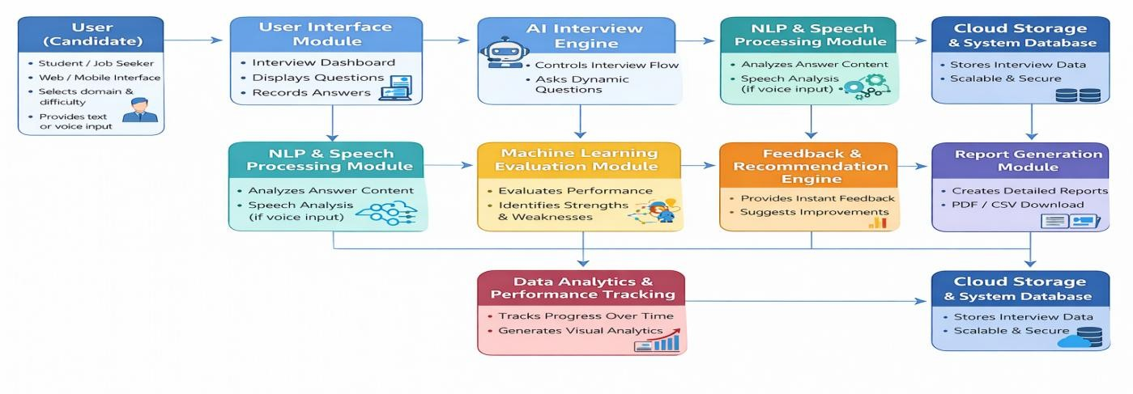
Fig 1

Working Diagram
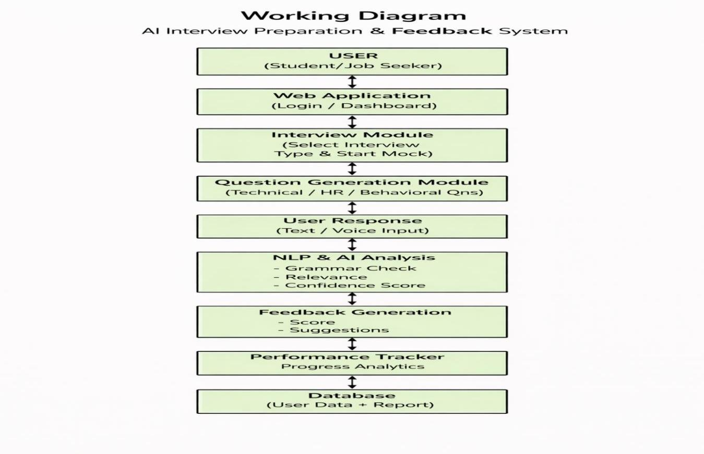
Fig 2

Working Diagram Description: The working diagram illustrates the overall workflow of the AI Interview Preparation & Feedback System. Initially, the user accesses the system through a web application where they log in and select the type of interview such as technical, HR, or behavioral interview. Once the interview session begins, the system generates relevant questions using the question generation module.
The user provides responses in text or voice format, which are captured by the system and sent to the AI analysis module. This module uses Artificial Intelligence and Natural Language Processing techniques to analyze the response. The system evaluates several parameters such as answer relevance, grammar accuracy, clarity of communication, and confidence level.
After analyzing the response, the feedback generation module produces a performance score along with suggestions for improvement. The results are stored in the database and displayed to the user in the form of feedback reports and progress analytics. This process helps users identify their strengths and weaknesses and improve their interview performance over time.
The AI Interview Preparation & Feedback System follows a layered system architecture that ensures scalability, efficiency, and real-time response analysis. The system is designed with multiple components including client interface, server layer, AI processing modules, services, caching system, and database storage. Each layer performs a specific function to provide a smooth interview simulation and feedback process.
- Client Layer
The client layer represents the user interface through which users interact with the system. Users access the platform using a web application where they can register, log in, select interview domains such as technical, HR, or behavioral interviews, and start mock interview sessions. The interface also displays feedback reports, performance scores, and improvement suggestions.
- DNS and Content Delivery Layer
The DNS layer resolves the domain request from the user and directs it to the correct server. A Content Delivery Network (CDN) helps deliver static resources such as UI files, scripts, and images quickly, improving system performance and reducing latency.
- Load Balancer
The load balancer distributes incoming user requests across multiple web servers. This ensures the system can handle multiple users simultaneously and improves reliability and fault tolerance.
- Web Server Layer
The web server handles incoming HTTP requests from users. It manages authentication, interview session initialization, and communication between the front-end interface and backend services.
- API Layer
The API layer acts as a bridge between the user interface and backend services. It includes multiple APIs such as:
Interview API – manages interview sessions and question flow
Response Analysis API – processes user answers
Feedback API – generates evaluation results
Search API – retrieves questions from the database
These APIs ensure smooth communication between system components.
- Memory Cache
A memory cache stores frequently accessed data such as commonly used interview questions and user session data. This improves response speed and reduces database load.
- Database Layer
The database layer stores all system data including user information, interview questions, responses, feedback results, and performance reports. A master database handles write operations while read replicas support read requests to improve system performance.
- Object Storage
Object storage is used to store large data such as recorded interview responses, reports, and downloadable feedback files.

CHAPTER 5

MODULES
- User Management Module:
The User Management Module is responsible for handling user registration, login authentication, and profile management.
It ensures secure access to the system by validating user credentials and allows users to update their personal information.
This module also manages password recovery and user sessions.
- Interview Question Module:
The Interview Question Module manages the storage and organization of interview questions.
It categorizes questions into technical, HR, aptitude, and behavioral types. It also supports random question selection and allows the admin to add, update, or remove questions from the database.
- Mock Interview Module:
The Mock Interview Module simulates a real interview environment by presenting questions to users one at a time.
It manages interview sessions, records candidate responses, and may include time limits for answering questions.
This module helps users gain practical interview experience.
- AI Evaluation Module:
The AI Evaluation Module analyzes the candidate’s responses using artificial intelligence techniques.
It checks answer relevance, correctness, keywords, grammar, and response time. Based on this analysis, it generates scores to measure candidate performance.
- Feedback Generation Module:
The Feedback Generation Module provides detailed feedback after interview completion.
It highlights strengths, identifies mistakes, and suggests areas for improvement. It may also provide correct answers and communication tips to help candidates perform better.
- Performance Tracking Module:
The Performance Tracking Module maintains records of user interview attempts and scores.
It helps users track their improvement over time by providing progress reports and identifying weak areas that require more practice.
- Admin Module:
The Admin Module allows the administrator to manage the system efficiently. It provides features such as managing interview questions, monitoring user activities, maintaining system data, and generating reports for system evaluation.
- Database Module:
The Database Module is responsible for storing and managing all system data including user details, interview questions, responses, scores, and feedback.
It ensures data security, proper organization, and quick retrieval when needed.
- Report Generation Module:
The Report Generation Module creates structured performance reports based on interview results.
It helps users understand their preparation level by showing score summaries, progress analysis, and improvement suggestions.

CHAPTER 6

ALGORITHMS
1. Process Behavior Analysis Algorithm
- Monitors process creation, termination, and abnormal CPU/memory usage.
- Detects unusual or hidden processes that may indicate keylogger activity.
- Correlates process behavior with historical baseline data to flag anomalies.
2. Signature-Based Detection Algorithm (YARA Rules)
- Scans files, memory, and processes for known malware patterns.
- Matches byte sequences, strings, or structural signatures against a rule set.
- Useful for detecting previously identified keylogger variants quickly.
3. Anomaly Detection Algorithm (Machine Learning)
- Uses statistical models or ML classifiers (e.g., Isolation Forest, One-Class SVM) to identify unusual system behavior.
- Detects deviations in process activity, network traffic, or file access patterns.
- Can identify zero-day or stealth keyloggers that do not match known signatures.
4. Memory Forensics Algorithm
- Extracts hidden processes, injected DLLs, and kernel hooks from memory dumps.
- Detects malicious artifacts not visible on disk.
- Correlates memory findings with process and event log data for verification.
5. Network Traffic Analysis Algorithm
- Monitors outbound connections and unusual network patterns.
- Detects command-and-control (C2) traffic and data exfiltration attempts.
- Uses statistical or ML-based anomaly detection to identify suspicious network flows.

CHAPTER 7

SYSTEM TEST
1. Unit Testing
Purpose: Verify individual modules perform their specific functions correctly.
Applied To:
User Module (registration and login validation)
Question Module (store and retrieve interview questions)
AI Evaluation Module (analyze answers and generate scores)
Feedback Module (generate suggestions and performance feedback)
Database Module (store user data and interview results)
Performance Tracking Module (record and display user progress)
Expected Result: Each module works correctly; users can register/login, questions are retrieved properly, answers are evaluated correctly, feedback is generated accurately, and performance data is stored successfully.

- Integration Testing
Purpose: Verify that different modules interact correctly with each other.
Applied To:
User Module with Interview Module (start interview after login)
Interview Module with AI Evaluation Module (send answers for evaluation)
AI Evaluation Module with Feedback Module (generate feedback from scores)
Feedback Module with Database (store results)
Expected Result: Modules communicate properly; interview answers are evaluated, feedback is generated, and results are stored without errors.

- System Testing
Purpose: Verify the complete system works according to requirements.
Applied To:
Complete interview workflow
Login → Interview → Evaluation → Feedback → Report generation
Expected Result: The full system operates smoothly with correct workflow and no functional errors.

- Performance Testing
Purpose: Verify system performance under different loads.
Applied To:
Multiple users taking interviews simultaneously
Database response time
Feedback generation speed
Expected Result: System responds quickly and supports multiple users without performance degradation.

- Security Testing
Purpose: Verify that user data is protected and system access is secure.
Applied To:
Login authentication
Password encryption
Admin access control
Database protection
Expected Result: Unauthorized access is prevented and user data remains secure.

- User Acceptance Testing (UAT)
Purpose: Verify the system meets user expectations.
Applied To:
User interface usability
Interview experience
Feedback usefulness
Report clarity
Expected Result: Users can easily use the system and find the feedback helpful for improving interview skills.
IMPLEMENTATION
SOURCE CODE:
from flask import Flask, request, jsonify
import random from datetime import datetime
app = Flask(__name__) # In-memory database usersDB = [] questionsDB = [
{
"id":1,
"question":"What is Python?",
"category":"Programming",
"difficulty":"Easy",
"type":"normal",
"expectedKeywords":["programming","language","interpreted"]
},
{
"id":2,
"question":"What is DBMS?",
"category":"Database",
"difficulty":"Easy",
"type":"normal",
"expectedKeywords":["database","management","data"]
}
]
# ================= USER MODULE =================
@app.route('/register', methods=['POST']) def register(): data = request.json
user = {
"username":data["username"],
"password":data["password"]
} usersDB.append(user)
return jsonify({"message":"User Registered"}) @app.route('/login', methods=['POST']) def login():
data = request.json for user in usersDB:
if user["username"] == data["username"] and user["password"] == data["password"]: return jsonify({"message":"Login Success"})
return jsonify({"message":"Invalid Login"})
# ================= QUESTION MODULE =================
@app.route('/questions/all')
def get_all():
return jsonify(questionsDB) @app.route('/questions/category/<category>') def category(category): result = [q for q in questionsDB if q["category"]==category]
return jsonify(result)
@app.route('/questions/difficulty/<difficulty>') def difficulty(difficulty):
result = [q for q in questionsDB if q["difficulty"]==difficulty]
return jsonify(result)
@app.route('/questions/random/<int:count>') def random_q(count):
shuffled = questionsDB.copy() random.shuffle(shuffled) return jsonify(shuffled[:count])
# ================= ADMIN MODULE =================
@app.route('/add-question', methods=['POST']) def add_question():
data = request.json
newQ = {
"id":len(questionsDB)+1,
"question":data["question"],
"category":data["category"],
"difficulty":data["difficulty"],
"type":"normal",
"expectedKeywords":data["keywords"]
} questionsDB.append(newQ) return jsonify({"message":"Question Added"})
# ================= AI EVALUATION =================
def evaluate(answer, keywords):
if not answer:
return 0
answer = answer.lower() match = 0 for k in keywords:
if k in answer:
match+=1
return int((match/len(keywords))*100)
# ================= FEEDBACK MODULE ================= @app.route('/feedback', methods=['POST']) def feedback():
data = request.json responses = data["responses"] totalScore = 0 categoryScore = {} detailed = []
for r in responses: q = next((x for x in questionsDB if x["id"]==r["questionId"]),None) if not q:
continue
score = evaluate(r["answer"],q["expectedKeywords"]) totalScore += score
# category tracking if q["category"] not in categoryScore:
categoryScore[q["category"]] = {
"total":0,
"score":0 }
categoryScore[q["category"]]["total"]+=100 categoryScore[q["category"]]["score"]+=score
detailed.append({
"question":q["question"],
"yourAnswer":r["answer"],
"score":score,
"keywords":q["expectedKeywords"]
})
avg = int(totalScore/len(responses)) return jsonify({
"overallScore":avg,
"performance":level(avg),
"analysis":analysis(categoryScore),
"recommendations":recommend(avg),
"detailedFeedback":detailed,
"date":datetime.now()
})
# ================= ANALYSIS =================
def level(score):
if score>=90: return "Excellent"
if score>=70:
return "Good"
if score>=50: return "Average" return "Needs Improvement"
def analysis(categoryScore):
result=[]
for cat,data in categoryScore.items():
percent = int((data["score"]/data["total"])*100) result.append({
"category":cat,
"score":percent
}) return result
def recommend(score):
if score>=80: return ["Practice advanced questions"]
if score>=50: return ["Improve weak topics","Revise fundamentals"]
return ["Study basics","Practice daily","Take mock tests"]
# ================= SERVER =================
if __name__ == '__main__': app.run(debug=True)

CHAPTER 8 OUTPUT SCREENS
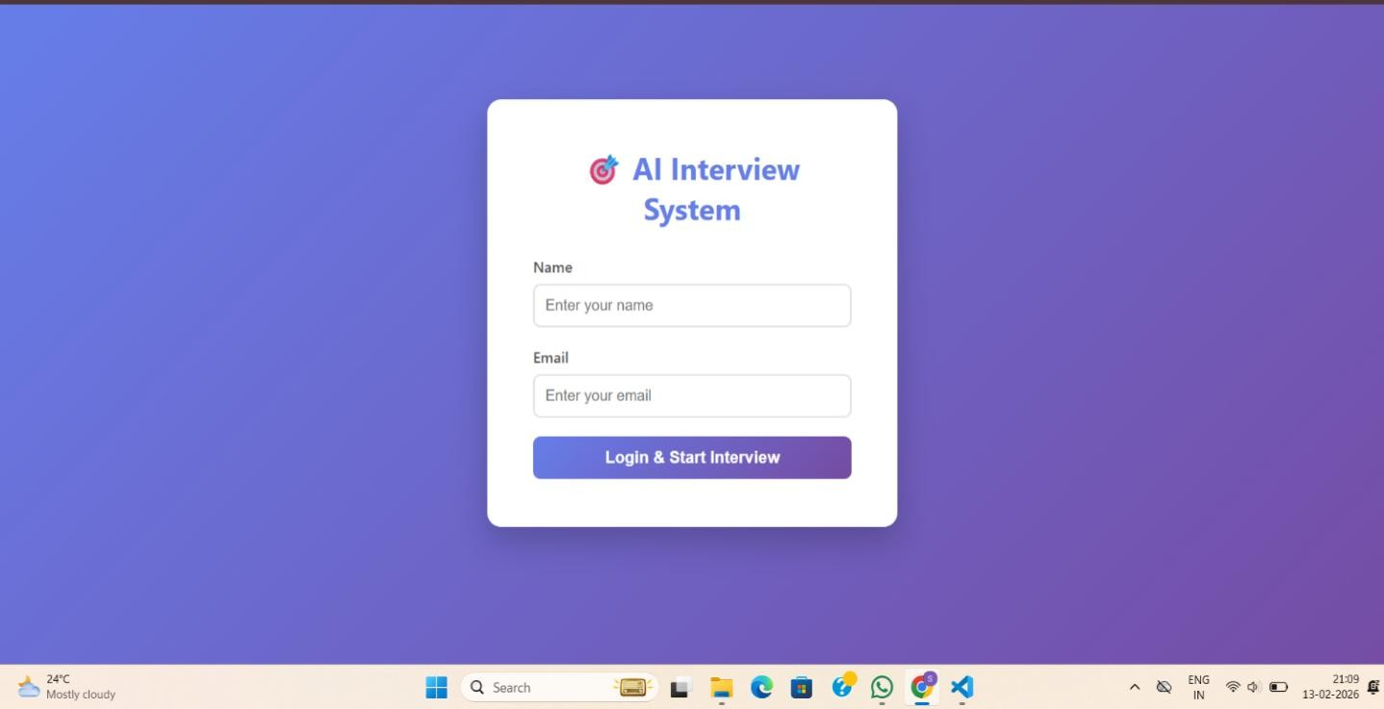
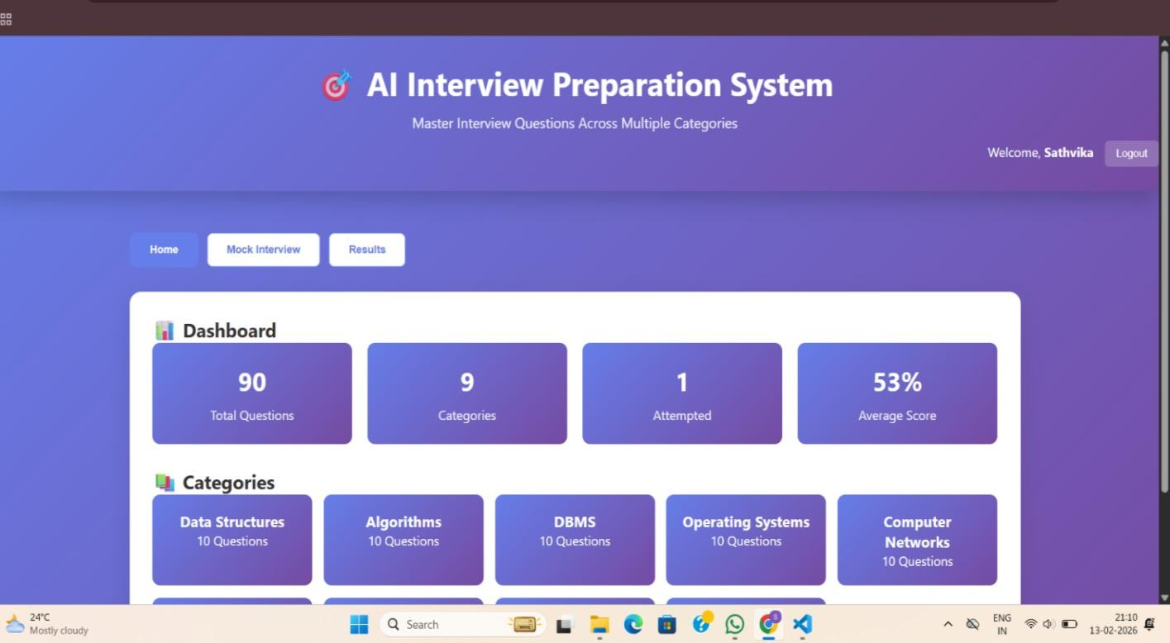

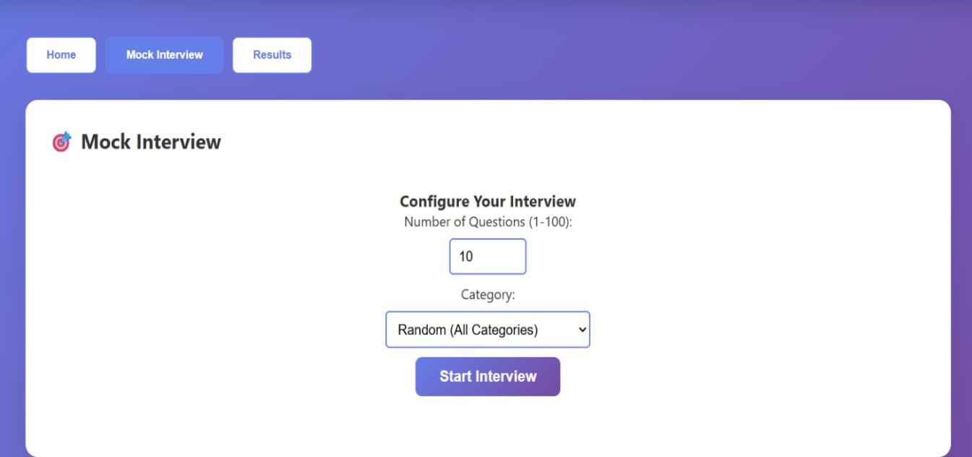
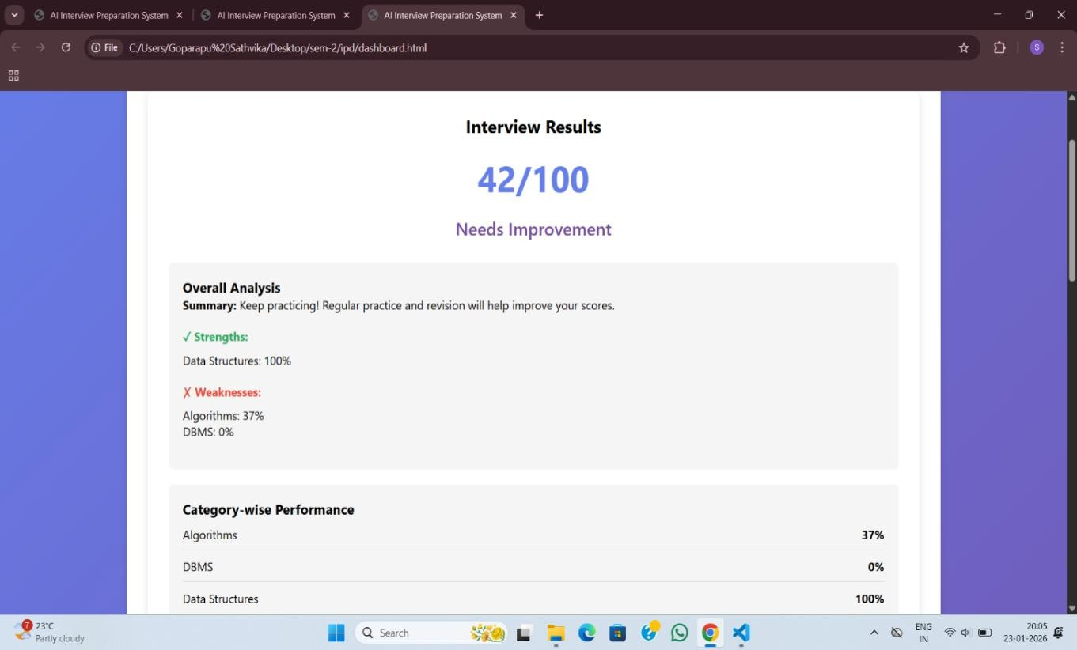
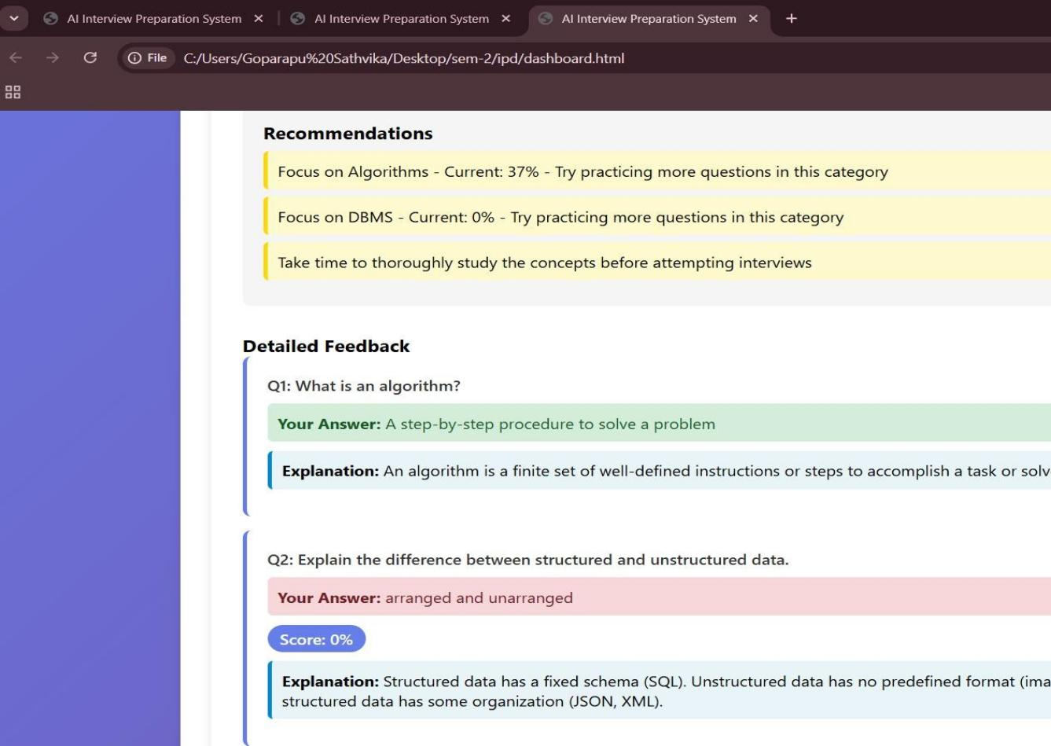

CHAPTER 9 CONCLUSION
The AI Interview Preparation and Feedback System is designed to help students and job seekers improve their interview skills through automated mock interviews and intelligent feedback. The system provides a structured platform where users can practice technical and HR questions, receive performance analysis, and identify their strengths and weaknesses. By using Artificial Intelligence techniques such as answer analysis, keyword matching, and performance scoring, the system makes interview preparation more effective and data-driven.
One of the major advantages of this system is that it reduces dependency on human interviewers and allows candidates to practice anytime and anywhere. It also helps reduce interview fear, improves communication skills, and builds confidence through repeated practice. The system is scalable and can be enhanced further by adding advanced AI features such as Natural Language Processing, speech analysis, resume-based question generation, and machine learning-based performance prediction.
In conclusion, the AI Interview Preparation and Feedback System provides an efficient, accessible, and intelligent solution for interview preparation. It bridges the gap between theoretical knowledge and practical interview performance, helping candidates become better prepared for real-world recruitment processes. Future enhancements can further improve the system by making it more intelligent, interactive, and personalized for users.

CHAPTER 10 FUTURE SCOPE
The AI Interview Preparation and Feedback System can be further enhanced by incorporating advanced features that make the platform more intelligent, interactive, and closer to real-world interview environments. Future improvements may focus on integrating advanced Artificial Intelligence techniques, improving user experience, and expanding overall system capabilities. One key enhancement is the use of Natural Language Processing (NLP) to understand the semantic meaning of candidate responses rather than relying solely on keyword matching, enabling more accurate evaluation and meaningful fee-+dback. Additionally, speech recognition can be introduced to support voice-based interviews and assess communication skills such as pronunciation, fluency, and confidence. The system can also be extended to include video interview simulation, where computer vision techniques analyze facial expressions and body language, helping candidates improve their non-verbal communication skills, which are essential for success in real interviews.
.

AI Interview Preparation And Feedback System

CHAPTER 11 REFERENCES
- A. Vaswani et al., “Attention Is All You Need,” in Proceedings of the IEEE Conference on Neural Information Processing Systems, 2017.
- T. Mikolov, K. Chen, G. Corrado, and J. Dean, “Efficient Estimation of Word Representations in Vector Space,” in Proceedings of the International Conference on Learning Representations (ICLR), 2013..
- J.Devlin, M. Chang, K. Lee, and K. Toutanova, “BERT: Pre-training of Deep Bidirectional Transformers for Language Understanding,” in Proceedings of NAACL-HLT, 2019.
- C. Manning, P. Raghavan, and H. Schütze, Introduction to Information Retrieval, Cambridge University Press, 2008.[5] Python Software Foundation, Python Documentation.
- S. Bird, E. Klein, and E. Loper, Natural Language Processing with Python, O’Reilly Media, 2009.
- Y. Goldberg, “A Primer on Neural Network Models for Natural Language Processing,” Journal of Artificial Intelligence Research, vol. 57, pp. 345–420, 2016.
[7]Goodfellow, Y. Bengio, and A. Courville, Deep Learning, MIT Press, 2016.
- T. Chen and C. Guestrin, “XGBoost: A Scalable Tree Boosting System,” in Proceedings of the 22nd ACM SIGKDD International Conference on Knowledge Discovery and Data Mining, 2016.
- D. Jurafsky and J. H. Martin, Speech and Language Processing, 3rd ed., Pearson, 2021.
- S. Russell and P. Norvig, Artificial Intelligence: A Modern Approach, 4th ed., Pearson, 2021.

